Product tags

Product tags are keywords for product identification. They are used to sort products by a certain feature and enable a specific, narrow product search. For example, if you sell apparel and want to create tags for T-shirts, they can be, for example, "t-shirt," "cotton," "polo."

To edit product tags that are displayed in the public store, go to **Catalog → Product tags**.

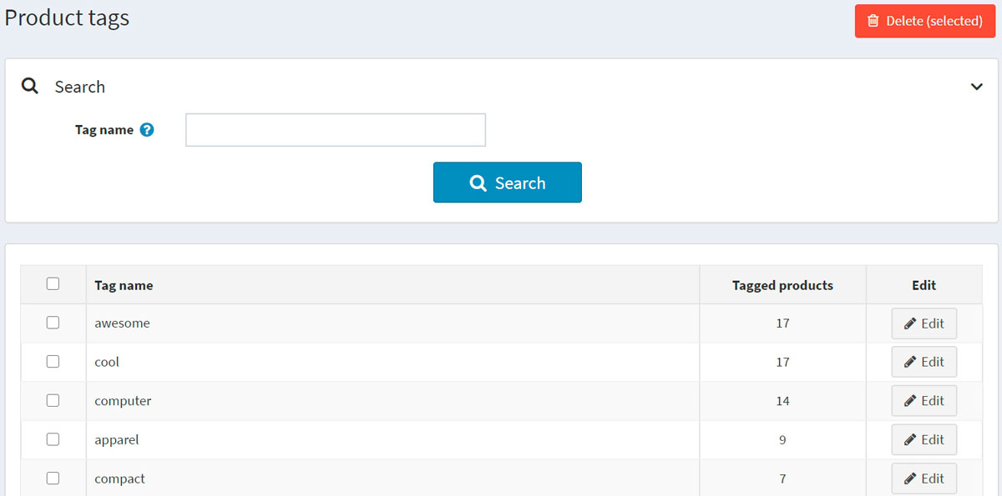

On the product tags page, you can see how many products have a certain tag in the **Tagged products** column. You can edit the tag by clicking the **Edit** button beside it. Or you can also delete tags by selecting them and then clicking the **Delete(selected)** button.

Adding product tags

You can add tags on the Edit product details page when adding or editing a product.

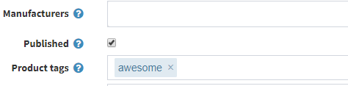

Enter tags, separating them by commas. Once the tags are created, they can be used for other products as well. The more products are associated with a particular tag, the larger it will look in the *Popular tags* area displayed on the sidebar of the catalog page:

